Search

David Murphy
11 August Development

An Intro Into TestFlight: External Testing

All data is invaluable for getting your app ahead of the game, so aggregating information pre­release can only be beneficial to your app’s success. That being said, TestFlight is both completely optional and completely free to use for all iOS developers.

There are two types of testing to review; internal (closed) and external (open).

Last time, we reviewed the process of initiating Internal Testing; now, let's focus on opening up your beta to External Users. Prerequisites:

­ An iTunes Connect Record

­ A pre­uploaded build of your app
Login to your iTunes Connect page and select My Apps

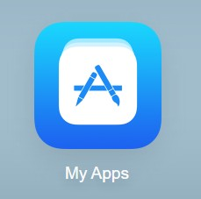

Open the Activity tab on the upper­most pane and scroll down to select the build to be tested; select the proper Version and Build
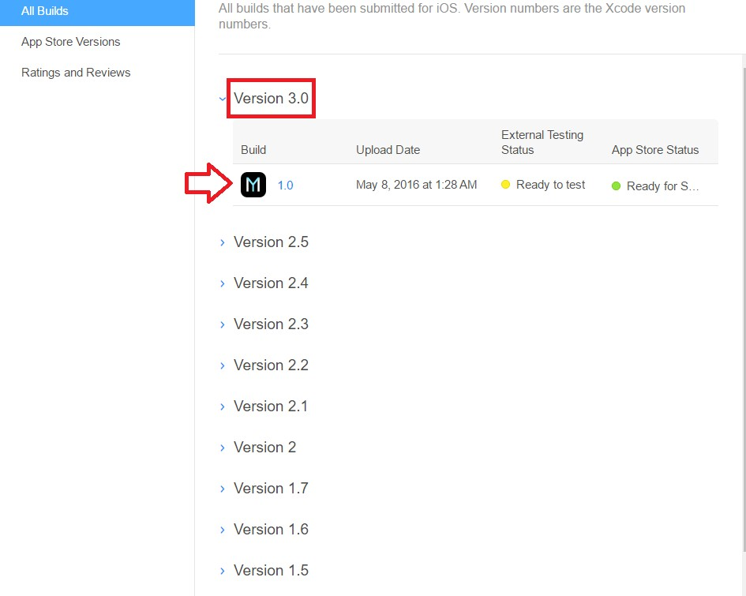


Click Test Information and leave instructions for testers to follow in What to Test. Provide other information for testers such as

Beta App Description, Feedback Email, and any other URLs
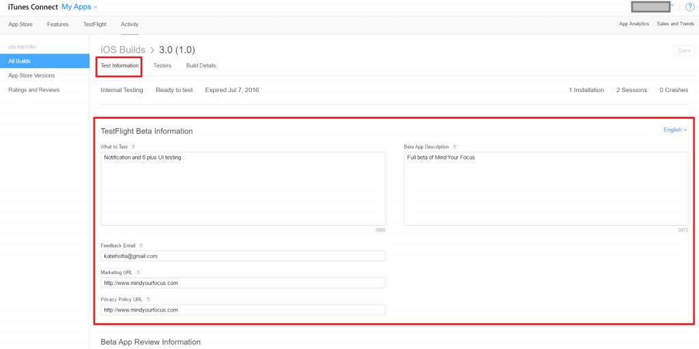

To invite External testers, navigate back to your app inMy Apps, select theTestFlighttab and clickExternal Testing

on the left­hand side.

Then, click the (+) beside the header that readsExternal Testersand start adding users
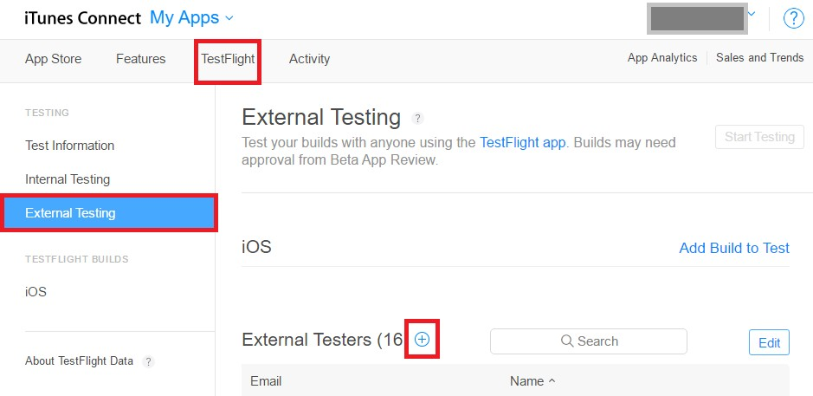

Check the box next to any eligible users who have not already been invited and clickAdd

NOTE 2000 invites is the current maximum capacity for External testing

All Apple ID users are eligible to be an external tester; but first, you’ll need to submit information for and receive approval from a

Beta App Review.
To submit one:

1. Click Add Build to Test from underneath the External Testing pane and select the build to be tested

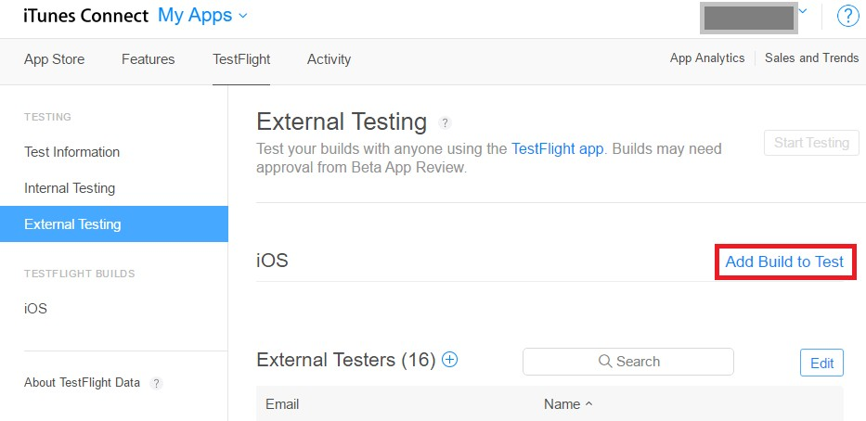

2. Select the build and clickAdd

3. Enter in your Test information

4. ClickNext

5. Answer Export Compliance questionnaire and click Submit

Upon approval, your build will be ready for testing; just click Start Testingunder the main TestFlight pane.

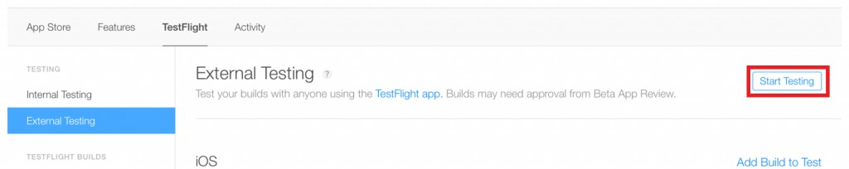

Emails will automatically be sent to those users you’ve added with both an attached invitation and a set of instructions for downloading the TestFlight App.
And now, it’s up to the recipients to either accept or decline your invitation.

If you’d like to discuss anything regarding your App, we’d be happy to learn more about it ­ just give us a shoutout! +1­646­741­4814

0

You might also like this articles

David Murphy
27 June

3 Easy Ways To Improve Your
Restaurant’s App

Restaurant apps are notorious for frozen payment transactions and horrific user accessibility. It's a shame, because a recent survey shows that 46% of users report that apps/websites with easier navigation would make them feel more comfortable with finishing a payment transaction.

0
David Murphy
04 June

Should I Develop My App Alone or With a Team?
Adopting a "me against the world" attitude is a trap that many appreneurs fall into. If you’re serious about your app’s growth, then you need to switch from a mindset of a coding hobbyist into that of a business owner.

0

